**Assignment 3 CRL707**

**Akashdeep Bansal (2016ANZ8049)**

**Q1**.

1. Cepstrum of the voiced and unvoiced segment

Voiced Segment

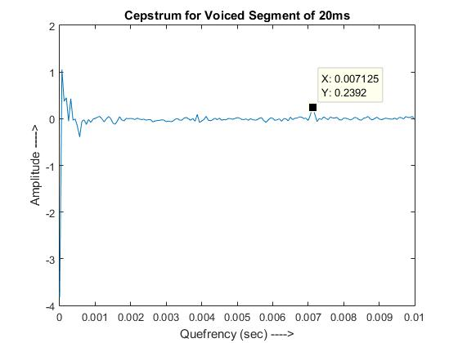

Unvoiced Segment

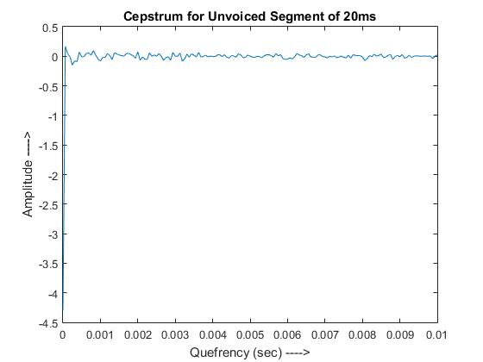

Voiced cepstrum has a peak whereas unvoiced cepstrum doesn’t have a peak. The peak at 0.007125 sec in the cepstrum of the voiced segment corresponds to the pitch period. Unvoiced sound doesn’t have the fundamental vibration, hence peak is not available in cepstrum of unvoiced sound.

1. **I) Lowpass ceptral lifter**

**Voiced Segment**

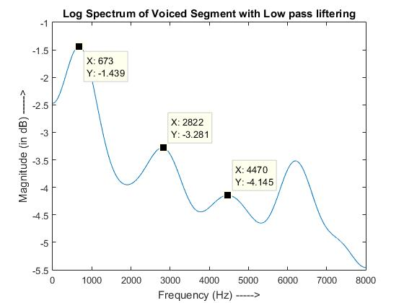

**Unvoiced Segment**

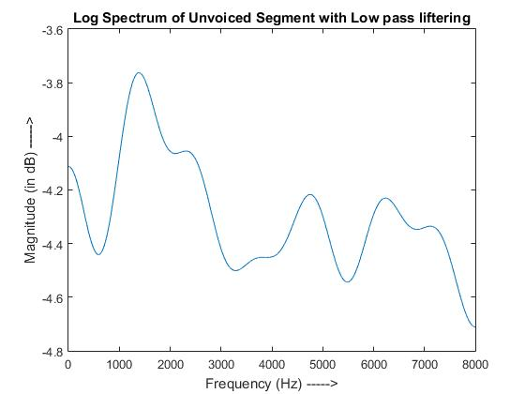

Voiced segment has formant frequencies at 673 Hz, 2822 Hz and 4470 Hz. Whereas, Unvoiced segment shows random pattern. Voiced segment have formants due to the resonance formation in the oral cavity.

**ii) Highpass cepstral lifter**

**Voiced Segment**

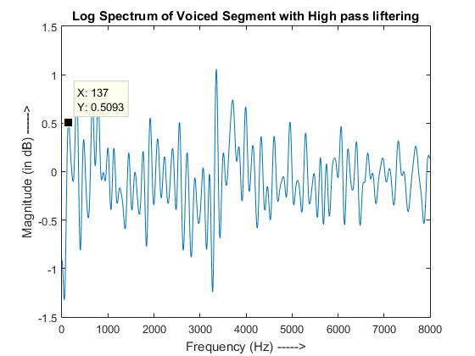

**Unvoiced Segment**

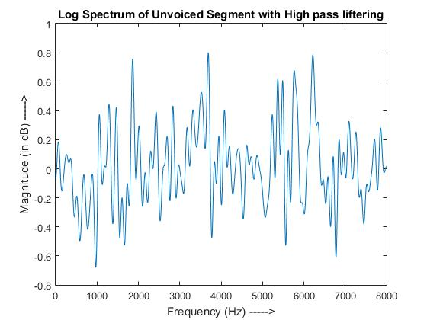

Again, due to the availability of the fundamental information, we can extract fundamental frequency from the log spectrum of the voiced segment after highpass ceptral liftering. Whereas, extraction of such information is not possible from unvoiced sounds.

1. **Time Waveform**

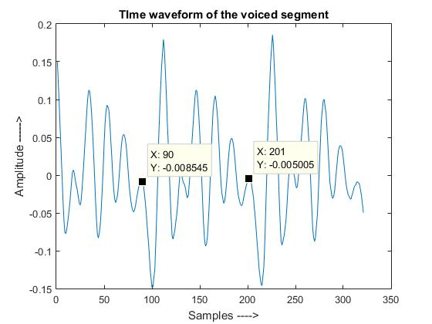

No. of Samples in one period = 201 -90 = 111

Pitch Frequency = 16000/111 = 144.14 Hz

**ii) Cepstrum of voiced segment**



Pitch frequency = 1/0.007125 = 140.35 Hz

**iii) Smooth log spectrum of voiced segment with highpass cepstral lifter**



Pitch frequency = 137 Hz